**Coursera Capstone**

IBM Applied Data Science Capstone

# Cities Divided by Iron Curtain new Opportunities

# Description of the Problem and a Discussion of the Background

By: Miroslav Danek

April 2021

**Prague**



vs

**Munich**

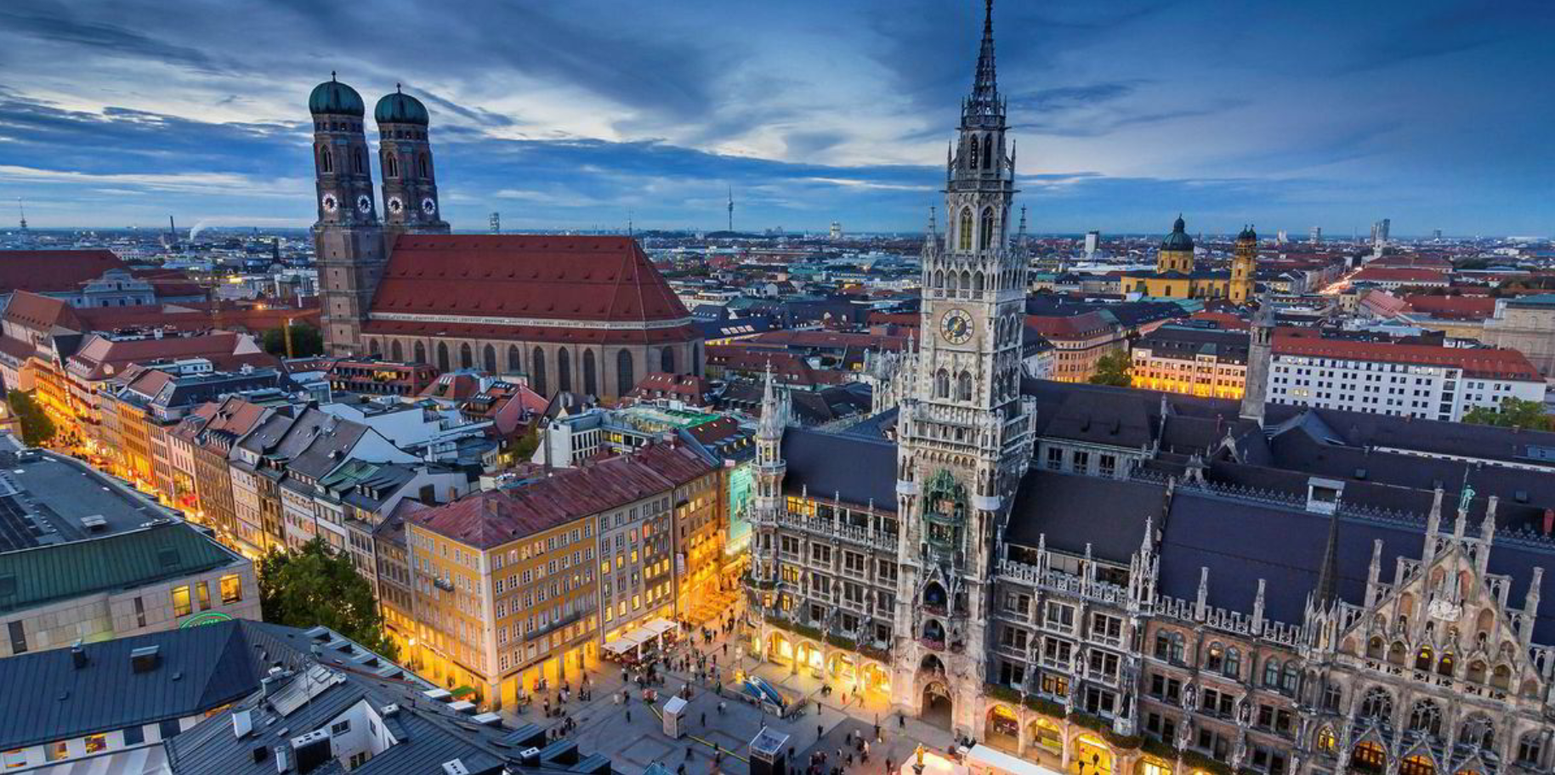

**Introduction**

Two cities with formerly very similar history and only 3,5 hours apart from each other, were divided with iron curtain for over 40 years. This long separation has changed the evolution of the isolated city Prague dramatically. But the iron curtain is history for almost 32 years. Prague is economically -measured by GDP one of the richest cities in EU. But are between these two cities still some differences, which could be caused by the 40 years lasting division?

**Business Problem**

The comparison of these two cities using the methods of data science, could reveal some new business opportunities. Probably in is some fields the convergence process of both cities not completed or in Munich are missing some venues which will come from the east in the future, as the relevance of the eastern economies will rise.

**Target audience**

This project useful for city administration or for entrepreneurs who have business in the areas descripted by the used data service four square. The all can benefit from knowing the differences of these two cities, which are both similar populated capitals of similar big states Czech Republic and Bavaria.

**Discussion Section and limitation of the Model**

In this project we rely on the data from the four-square service. This API has found more unique venues in Munich than in Prague.